sxcPopular Video Game Sales

by region & year.

**Basic Info.**

Working project title: Popular Video Game Sales by region & year.

Karl Buckley, UID: u1417778, Email: [u1417778@umail.utah.edu](mailto:u1417778@umail.utah.edu)

Dominic Malouf, UID: u1194321, Email: [u1194321@umail.utah.edu](mailto:u1194321@umail.utah.edu)

Chris Stevenson, UID: u0679323, Email: [u0679323@utah.edu](mailto:u0679323@utah.edu)

Repository link: <https://github.com/RosyGraph/datavis-final-project>

**Background and Motivation.**

When looking for a dataset to work with, the group was very open to suggestions as there were no overriding motivations or existing project ideas. We wanted to find a dataset that would be fun to work with, show interesting data and leave us with some innovative and different visualization style options. Having some background in video games meant that each team member would have some experience and frame of reference for the data and the project can be utilized by anyone wanting an insight into video game sales by region.

**Project Objectives.**

The primary question the data will be answering would be “What are the worldwide sales figures, by region, of the most popular video games between 1982 and 2016?”

This data also provides answers to a lot of other questions such as:” Which region had the most sales of X video game?” or “Which video game sold the most copies between 2002 and 2005?”

This data will enable us to build a picture of the Video Game sales landscape between 1982 and 2016 to provide trends and patterns that show which games sold the best, where they sold and maybe we will get some insights into why games sell differently in each region to build an idea of the video game markets in each region.

**Data.**

We are sourcing our data from the online data repository Kaggle. It is authored by A. Ingle and there is no accreditation as to where the data was originally collected from. Here is the kaggle link: <https://www.kaggle.com/datasets/atharvaingle/video-games-dataset>

**Data Processing.**

For this project, the group does not foresee needing to perform any data processing further than what has already been supplied. The data is given as a .csv file which is compatible with our methods and the data is already categorized into Rank, Name, Year, Genre, Publisher, N. America, Europe, Japan, Other and Global sales. It may be required for us to remove the “Other” data if it shows during the data analysis that we only need the “Global” sales figures and the three main sales markets.

**Visualization Design.**

The visualization needs to be compelling as it is displaying statistics of sales numbers and given the subject matter, it should allow for bright, eye-catching visuals and interactions.

(Develop **three alternative prototype designs for your visualization**. Create **one final design that incorporates the best of your three designs**. Describe your designs and justify your choices of visual encodings.)

* Designs at the end of document

**Must-Have Features.**

The most important feature of the visualization is that it must display a comparison of sales figures for each game against each region and each game. Once we have that main data, it is possible to display this data in a clear, concise but enjoyable format that encourages exploration of the data. Without this functionality, the project will have failed to educate the viewer on video game sales.

**Optional Features.**

Direct manipulation of the data will be the main feature that elevates this project allowing the comparison of different data to provide insights into sales trends across regions. Allowing for the easy selection of data and providing an interaction that not only provides entertainment but also an insight into the data is the aim of the project. Being able to select multiple games and seeing how they perform against one another in each region will provide insights into player populations, spending habits and gaming trends.

**Project Schedule.**

In order to complete the project by the deadline, the following schedule can be followed to make sure the project is managed correctly, and the team members know which milestones are due.

**Week 9**: Complete the project proposal document, each team member designs and describes a visualization for the data to include in the proposal. As a group, choose the final design and complete any final design ideas and suggestions.

**Week 10** – Work on initial prototype for the visualization, one team member to focus on interactions, one to focus on displaying the data and one on visuals and design choices.

**Week 11** – Complete the codebase for the project and have all team members fixing bugs and errors with the prototype. Update and have initial first draft of the Process Book

**Week 12** – Project Milestone Hand In. Must have an initial Process Book, codebase, dataset and update git repo with readme file, all project files and code.

**Week 13** – Receive project feedback from Instructors. Implement feedback and changes needed from peer feedback. More bug testing of new implementations and any design/code changes.

**Week 14** – Team members working on the project website, one team member to create the required screen capture and edit the video. Last team member to work on any outstanding issues, adding any last-minute features.

**Week 15** – Final review and proof-read by the team and Final Project hand in.

**Design One:**

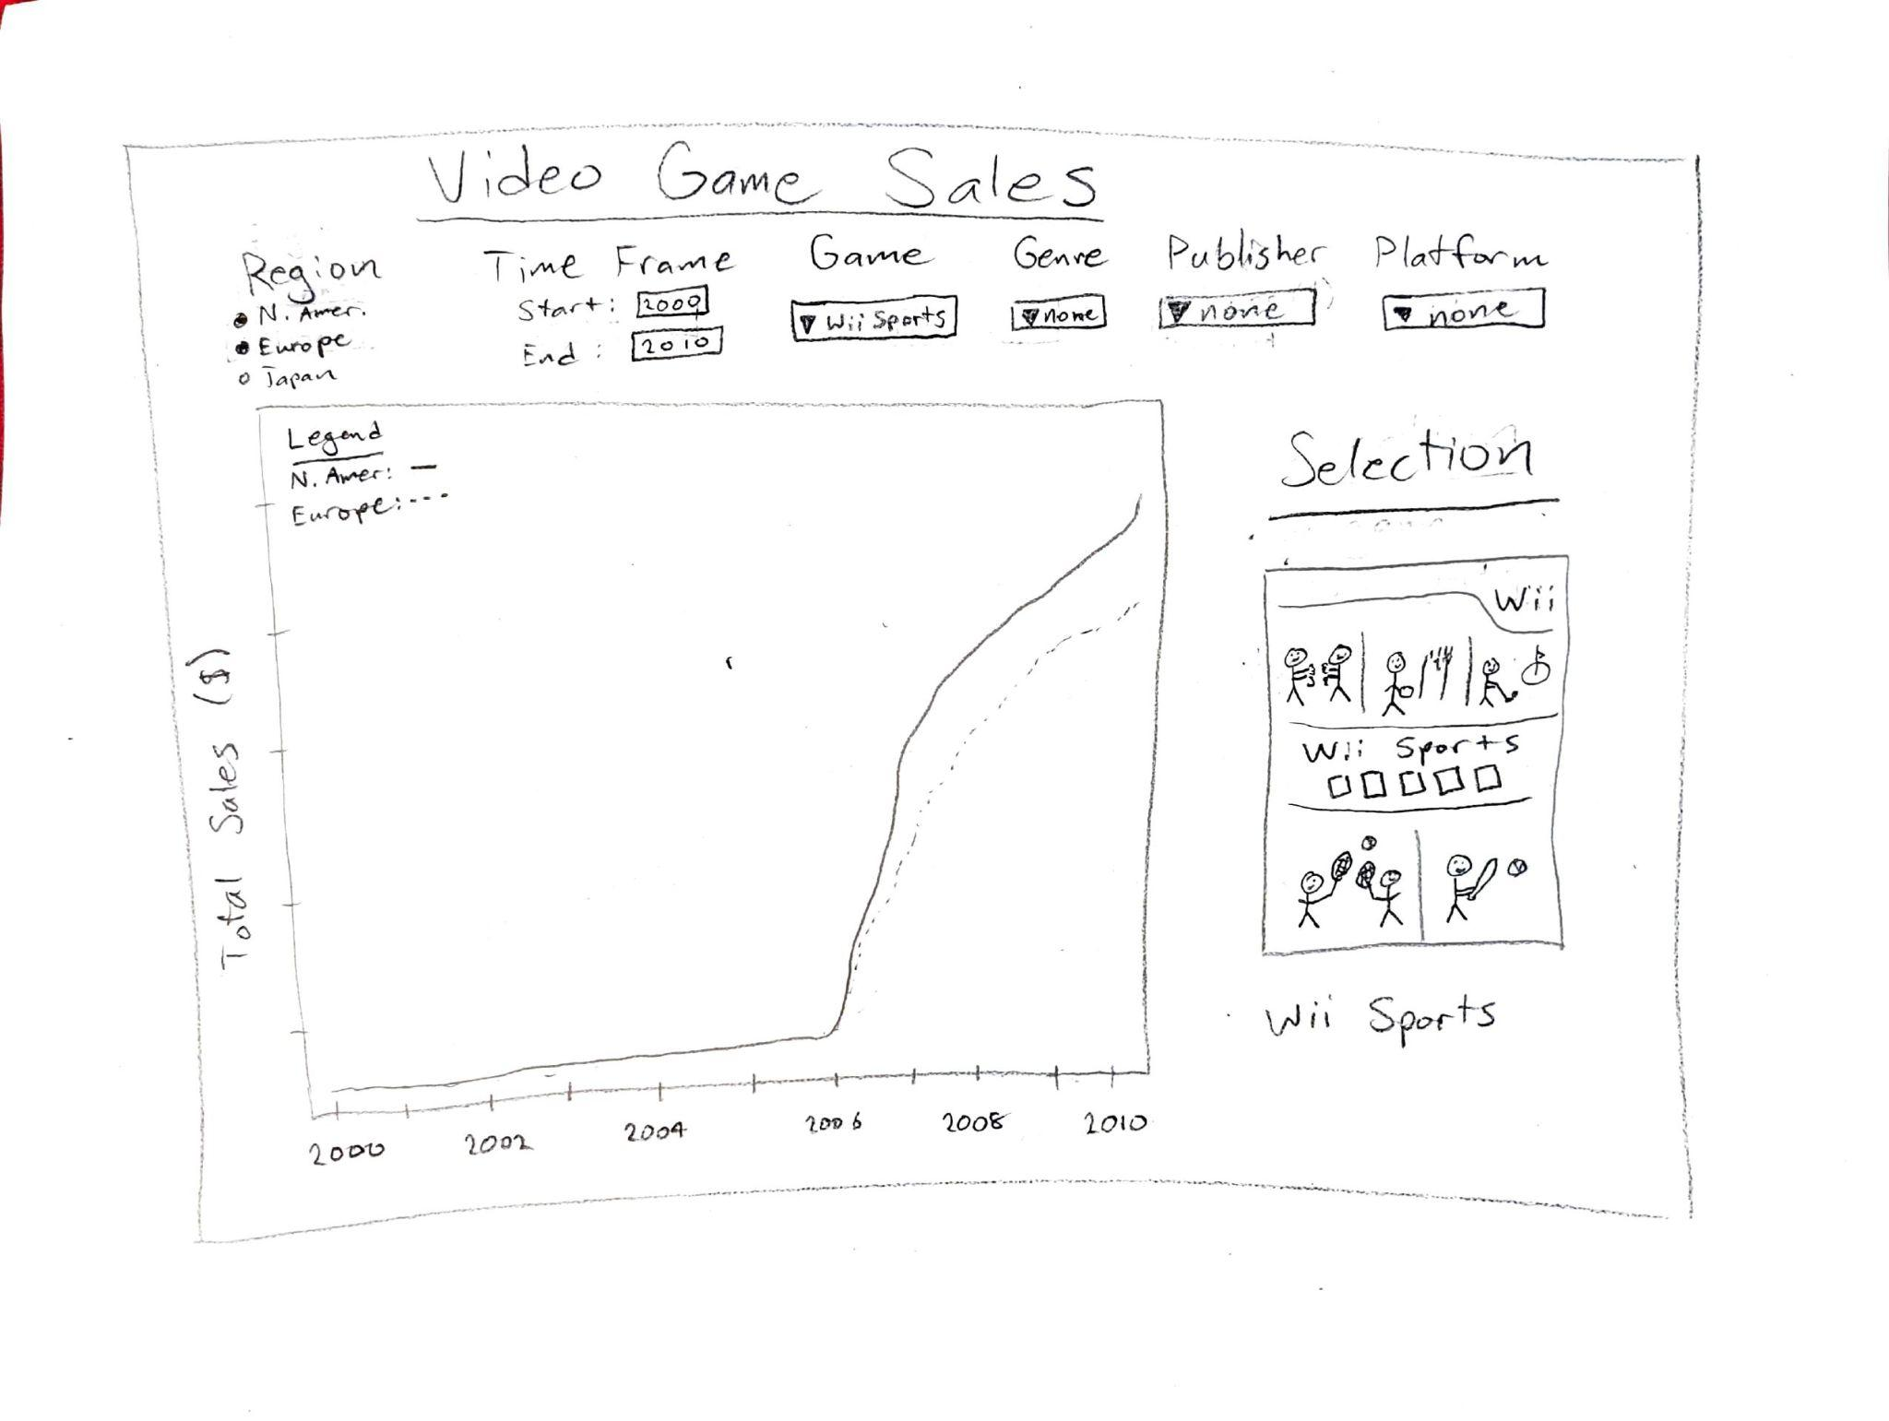

This design uses variable selectors to modify a single graph. The tabs at the top will drop down and allow for the user to select which variable they would like to be visualized. When one is selected it could make the other menus unavailable (for example if a single game is selected, then a publisher could not be selected because each game has only one publisher). Some tabs can also have multiple variables selected at once (in this case the graph will add more lines and update the legend accordingly)

**Design Two:**

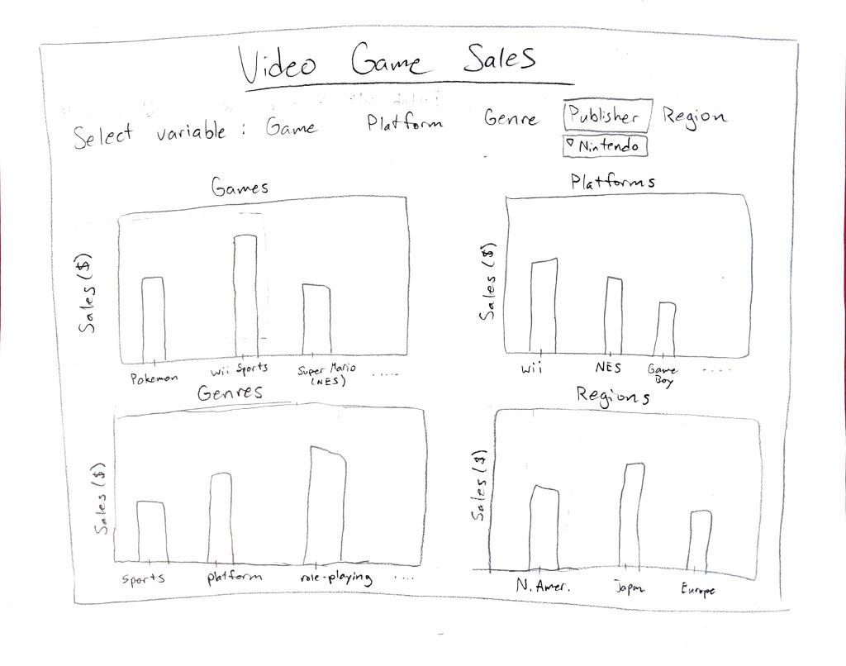

This design uses a similar mechanic to the first design, but here only one variable is selected and the unselected variables are shown as graphs. If a specific platform were to be selected, the graph containing platforms would switch to publishers. This design benefits from the data not being crowded to one graph as well as having the user interact with all graphs using the top menu.

**Design Three:**

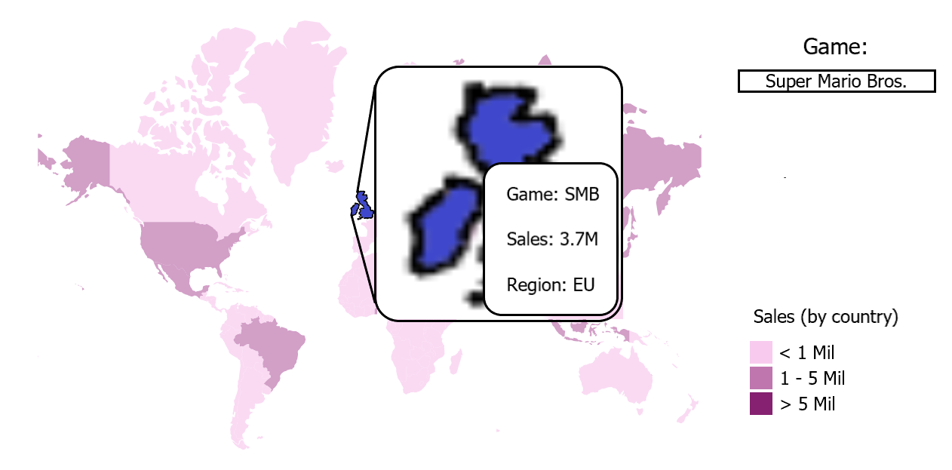

This design has been developed to display the world map with context sensitive bubbles that show further information regarding sales figures for each country. The design here is to promote exploration rather than tell a narrative about the data as it allows each viewer to drill down into the data for each game by publisher/year and number of sales. There exists the opportunity to expand this design further with a time scale slider to allow data changes over time and further comparison between publishers and individual titles.

**Design Four:**

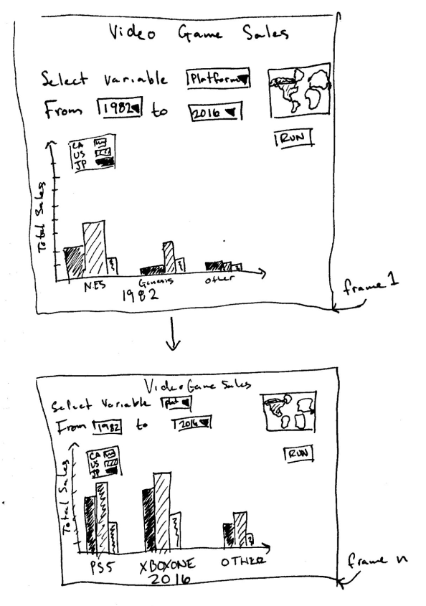

This design uses an animation to display a selected time series. The user may select the variable for the x-axis and select a collection of countries. If no country is selected, then the continents (minus Antarctica) will be displayed instead. The animation transitions the bars in the chart depending on their value from year to year.

**Final Design:**

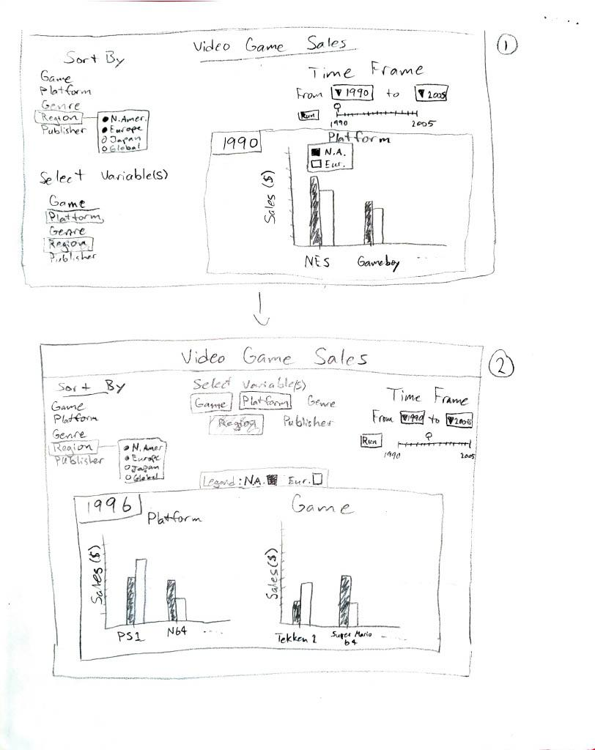

This design lets the user select a main variable to graph, in this case region. Graphs are then created by selecting from the remaining variables, each variable appends a new graph to the screen. All graphs are controlled by the Time Frame section. The year can be selected manually, or hitting Run will animate the graphs from the time frame selected (same as design 4). The difference in frame 1 from frame 2 is that the controls are moved. These are possible spots for the variable selectors, but their spots on the screen are open to change. Same as with the section of the screen that houses the graphs and the legend.